APPLICATION FORM

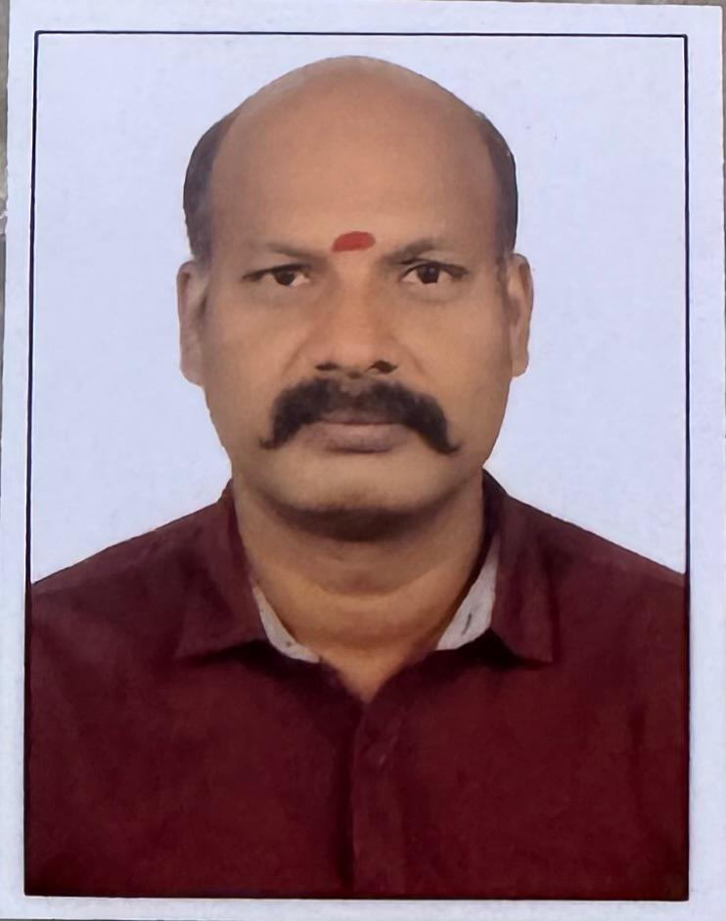

Attach Passport Size Photo Here

Batch No:

# Name of Counselor :

**AKILA G**

# Branch:

**CHENNAI**

# Application for Admission:

**MBA- DUAL SPECIALIZATION**

1. Specialization in : * **MBA- EXPORT MANAGEMENT & FINANCE MA**

# Full Name in Block Letters :

**RAVIKUMAR R**

**15/02/2024**

# Date of Birth (DD/MM/YYYY) :

1. Gender : Male:

✔

# Female:

Others:

# Status : Married: Unmarried:

✔

1. Nationality : **INDIAN**
2. Father’s / Husband’s Name : **RAJENDIRAN**

# Temporary Address :

House No : **3,**

# Landmark:

House Name : District: **KANCHEEPURAM**

# Street or Road :

**CHILDREN STREET, MUNGIL**

State :**TAMIL NADU**

# Place :

**PAMMAL**

Pincode : **600075**

# Permanent Address:

House No :

**SAME AS**

# Landmark:

House Name : District: Street or Road : State : Place : Pincode :

# Telephone (Landline Number):

Mobile Number:

**+91 98407 83343**

Alternate Mobile Number: **+91 90809 73585, +91 96001 21314**

E-mail ID: [**sribommihairimpex@yahoo.com**](mailto:sribommihairimpex@yahoo.com)

For Office Use Only:

# Reference No: Batch No: Admission Approve by: Code No:

1. Academic Details : Examination taken (Please list in chronological order including examinations with result pending:

|  |  |  |  |  |
| --- | --- | --- | --- | --- |
| **Degree** | **Name of Institute** | **Exam Date (MM/YY)** | **Subjects** | **Grade/ Percentage** |
| **BCOM** | **UNIVERSITY OF M** | **2008** |  | **75%** |
|  |  |  |  |  |
|  |  |  |  |  |
|  |  |  |  |  |

# Work Experience (Starting with most recent one)

|  |  |  |
| --- | --- | --- |
| **Name of the Company** | **Designation** | **Years/Months Worked** |
|  | **SELF EMPLOYEE** |  |
|  |  |  |
|  |  |  |
|  |  |  |

1. Mode Of Payment :

# By Cash:

By Cheque:

# Online :

1. Bank Name: Fees Paid: **6000/-**

✔

# PDC First PDC Second

Cheque No : Cheque No: Date : Date:

# Amount : Amount:

**Terms & Conditions** : * Xerox copies of age proof, address proof, Mark sheets, certificates in proof of all examinations, work experience Certificates, two passport size photographs should be attached to this application form.

* Fees should be paid either by cheque, DD or cash. Cheque / DD favoring "Norwich Institute Of Management Studies" payable at Thrissur, Kerala State, India. * Fees once paid will not be refunded under any circumstances. * All diploma courses/ Certificates offered/ issued by this institute has no government university accreditation or recognition and is only a private autonomous body program/ certification. * All courses offered by N.I.M.S analyzes only the theoretical knowledge & abilities of the student, while assuming that practical & technical expertise have been acquired by the student himself, through his work experience and exposure to respective field over a period of time. * Please keep a Xerox copy of this application form for your record and reference. * All legal complaints regarding this institute and courses provided b y it falls under jurisdiction of Thrissur District, Kerala State.

# **Declaration By The Candidate** : I certify that all information provided on this application Performa is complete and accurate. I agree to familiarize myself with all the rules and regulations of the program set forth by N.I.M.S and abide by them. I would uphold the standards and respect the principles of

N.I.M.S as an organization of higher learning.

✔

Date: **24/02/2024**

Signature : 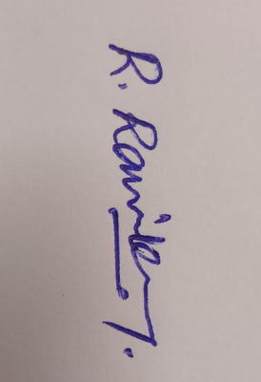 Place: **CHENNAI**